Introduction
Your Health is a modern telemedicine platform designed to transform the healthcare experience by offering convenient, accessible, and secure medical consultations. This platform allows patients to receive immediate medical advice and guidance through AI-powered tools and virtual consultations with licensed healthcare providers. Your Health aims to address the challenges of traditional healthcare by eliminating geographic barriers, reducing costs, and providing quick access to medical care. With a focus on privacy, security, and patient-centric services, Your Health empowers both patients and doctors, making healthcare more efficient and user-friendly.

Overview
Your Health is an all-in-one telemedicine system that offers a variety of services to improve access to healthcare. It features real-time video consultations with licensed doctors, allowing patients to seek medical advice and receive diagnoses remotely. The platform also includes an AI-powered first aid assistant that provides instant guidance based on symptoms, helping patients manage minor health issues or decide whether to seek further care. All patient data is securely stored and managed in a centralized database, making it easy for doctors to track patient history, prescriptions, and medical records. With a simple, user-friendly interface, Your Health offers a convenient healthcare solution that can be accessed from any device, anywhere.

Motivation
The motivation behind Your Health stems from the increasing demand for more accessible, affordable, and efficient healthcare services. Traditional healthcare systems often face challenges such as long wait times, high costs, and limited access to medical professionals, especially for people in remote or underserved areas. Additionally, many individuals struggle with the inconvenience of in-person appointments, transportation issues, and the complexity of managing multiple healthcare records. Your Health was created to solve these problems by providing a digital platform that connects patients with healthcare professionals through virtual consultations, improving both access to care and the overall patient experience.

Problem Statement
Today’s healthcare system faces several critical problems that hinder the effectiveness and accessibility of medical care:
- Limited Access to Healthcare: Many people in rural or underserved areas struggle to access healthcare, especially specialists, due to geographic barriers.
- High Healthcare Costs: The cost of in-person doctor visits, transportation, and hospital stays often creates financial strain for patients.
- Long Wait Times: Traditional healthcare often involves long wait times for appointments, leading to delays in receiving care.
- Privacy and Security Concerns: Patients are concerned about the safety and confidentiality of their medical information in digital platforms.
- Inconvenient Care: Busy schedules, mobility issues, or transportation challenges make it difficult for patients to visit doctors in person, especially for non-urgent issues.

Objectives
- To increase healthcare access: Provide a platform that allows patients, especially those in remote or underserved areas, to access medical care without the need for travel.
- To reduce costs: Offer affordable healthcare services by eliminating transportation and in-person consultation fees, making healthcare more accessible to a wider audience.
- To provide immediate medical advice: Implement AI-powered tools that offer instant guidance and first aid recommendations based on symptoms, ensuring patients receive timely advice before seeking professional consultation.
- To ensure data privacy and security: Protect patient data through secure storage solutions and compliance with privacy regulations like HIPAA, ensuring confidentiality and building trust.
- To support continuous care: Enable doctors to track and update patient medical records, providing seamless follow-up care and ensuring accurate and consistent treatment over time.
- To promote convenience: Offer a user-friendly platform that allows patients to consult healthcare providers anytime, from anywhere, making healthcare more flexible and accessible.

Features
- AI-Powered First Aid Assistant: An intelligent tool that analyzes symptoms entered by patients and offers immediate advice on how to manage health issues.
- Real-Time Video Consultations: Secure video calls between patients and licensed healthcare professionals for diagnoses, treatment plans, and follow-up consultations.
- Patient Record Management: A centralized system for storing and accessing patient medical records, ensuring that all health information is up-to-date and readily available.
- Prescription Management: Doctors can prescribe medications directly through the platform, and prescriptions are securely stored for future reference.
- Secure Data Storage: All patient data is encrypted and stored in compliance with privacy regulations, ensuring that sensitive information is protected.
- Appointment Scheduling and Notifications: Patients can easily schedule appointments, and reminders ensure they don’t miss consultations.

Monetization Strategies:
- Pay-Per-Consultation: Charge users a fee for each consultation or checkup, generating revenue per session.
- Subscription Model: Offer a monthly or yearly subscription for unlimited consultations and services.
- Prescription Commissions: Earn a commission on prescriptions filled through partnered pharmacies.
- Corporate Partnerships: Provide corporate health plans, charging companies for bulk subscriptions for their employees.
- Advertising: Display relevant healthcare ads and sponsored content to generate income from healthcare brands.
- Premium Features: Offer additional paid services like expert consultations or personalized health plans.
- Data Insights: Sell anonymized health data to research institutions or healthcare providers (with user consent).
- Telemedicine Equipment Sales: Sell or lease health monitoring devices like blood pressure monitors or wearables to users.

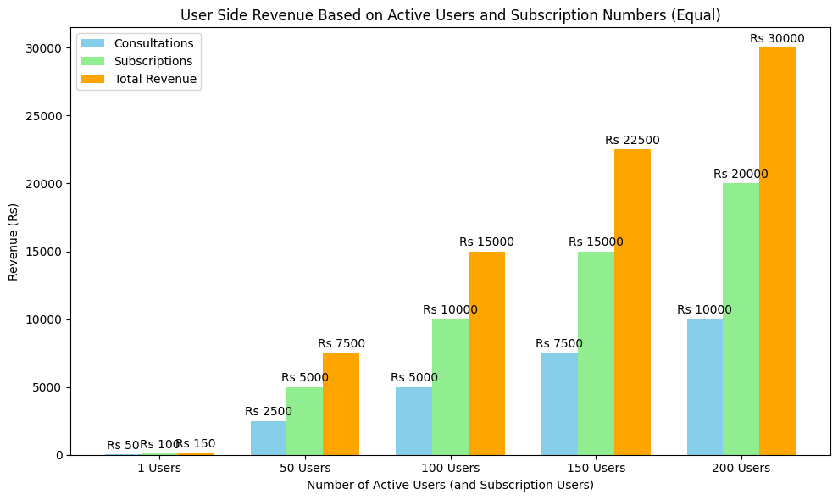
SN | Active Users (and Subscription Users) | Revenue from Consultations (Rs) | Revenue from Subscriptions (Rs) | Total Revenue (Rs)
0 | 1 | 50 | 100 | 150
1 | 50 | 2500 | 5000 | 7500
2 | 100 | 5000 | 10000 | 15000
3 | 150 | 7500 | 15000 | 22500
4 | 200 | 10000 | 20000 | 30000

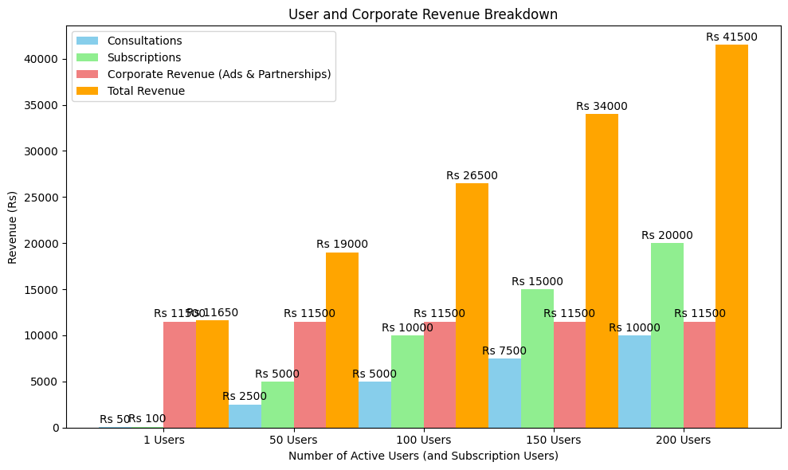

SN | Active Users | Revenue from Consultations (Rs) | Revenue from Subscriptions (Rs) | Corporate Revenue (Ads & Partnerships) (Rs) | Total Revenue
0 | 1 | 50 | 100 | 11500 | 11650
1 | 50 | 2500 | 5000 | 11500 | 19000
2 | 100 | 5000 | 10000 | 11500 | 26500
3 | 150 | 7500 | 15000 | 11500 | 34000
4 | 200 | 10000 | 20000 | 11500 | 41500

Methodology
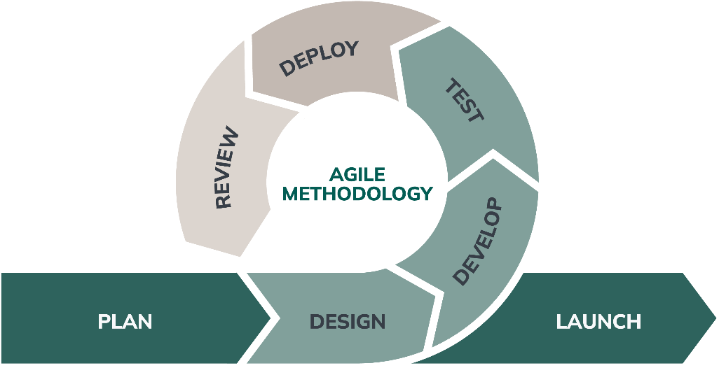

Technologies

1. Frontend (User Interface)
- HTML5, CSS3, JavaScript: These are the core technologies for building the structure, design, and interactivity of the website or web app.
- Frontend Frameworks:
  - React.js: A popular JavaScript library for building interactive user interfaces.
  - Vue.js: A progressive JavaScript framework for building UIs.
  - Angular: A comprehensive frontend framework, ideal for large-scale applications.
- CSS Frameworks:
  - Bootstrap: A widely used CSS framework for responsive design.
  - Tailwind CSS: A utility-first CSS framework for designing modern UIs.
- Mobile App Development (if required):
  - React Native: For building cross-platform mobile applications (iOS and Android).
  - Flutter: A UI toolkit for building natively compiled applications for mobile, web, and desktop from a single codebase.

2. Backend (Server-Side Technologies)
- Programming Languages:
  - Node.js (JavaScript): For building scalable and fast backend services.
  - Python: Popular for its simplicity and versatility. Frameworks like Django or Flask can be used for building secure and scalable backends.
  - Java: Well-suited for enterprise-level applications, with frameworks like Spring Boot.
  - Ruby: With the Ruby on Rails framework, which is great for rapid application development.
- Web Frameworks:
  - Express.js: A minimal and flexible Node.js web application framework.
  - Django (Python): A high-level Python web framework that promotes rapid development and clean, pragmatic design.
  - Flask (Python): A lightweight Python web framework suitable for building small to medium-sized applications.
- APIs (Application Programming Interfaces):
  - REST API: Representational State Transfer (REST) APIs will allow communication between the frontend and backend.
  - GraphQL: A modern alternative to REST, allowing clients to query only the data they need.
  - WebSockets: For real-time communication (like video calls and live chat).

3. Video Consultation and Communication
- WebRTC: A real-time communication protocol for video and audio calls in the browser, essential for video consultations.
- Twilio API: A platform for integrating messaging, voice, and video communications.
- Agora.io: A real-time communication SDK for adding video and audio calls to your application.
- Zoom API: For integrating Zoom video calls into your platform.
- Jitsi: An open-source platform for video conferencing.

4. AI and Machine Learning (For Symptom Diagnosis and First-Aid Suggestions)
- Python (Libraries):
  - TensorFlow or PyTorch: For building machine learning models to help diagnose symptoms or provide AI-driven recommendations.
  - Scikit-learn: A library for simple and efficient tools for data mining and data analysis.
  - OpenAI API: To integrate language models (like GPT-4) for symptom analysis and medical advice.
- Natural Language Processing (NLP):
  - spaCy: An NLP library for processing and understanding human language, useful for interpreting user queries or symptoms.
  - NLTK: The Natural Language Toolkit, which can be used for processing human language data.
- Cloud Services for AI:
  - Google AI/ML services: Pre-built AI services for symptom analysis, image recognition, etc.
  - IBM Watson Health: For advanced healthcare-related AI services like patient data analysis, symptom checkers, and predictive modeling.

5. Database Technologies
- SQL Databases:
  - MySQL: A popular relational database management system.
  - PostgreSQL: An open-source, object-relational database system with advanced features.
- NoSQL Databases (for scalability and flexibility):
  - MongoDB: A NoSQL database, good for handling large amounts of unstructured data.
  - Firebase: Real-time database service for mobile applications.
- Cloud Databases:
  - Amazon RDS: Managed SQL databases on AWS.
  - Google Cloud Datastore: A NoSQL database from Google Cloud.
  - Firebase Firestore: NoSQL document database for storing data in real-time.

6. Security and Compliance
- OAuth 2.0: For secure user authentication and authorization (important for patient privacy and HIPAA compliance).
- JWT (JSON Web Tokens): For secure user authentication in a stateless way.
- SSL/TLS Encryption: For secure data transmission, protecting sensitive patient and doctor data.
- HIPAA-compliant infrastructure: Ensuring all health-related data storage and transmission adheres to HIPAA standards for privacy and security.

7. Payment Integration (for Consultations and Subscriptions)
- Stripe: For handling payments, including subscription payments and per-consultation charges.
- Razorpay: A payment gateway widely used in South Asia for handling payments, including subscriptions and one-time charges.
- PayPal: For global payment solutions.
- Flutterwave: For payment processing across multiple countries, especially in African markets and some parts of Asia.

8. Cloud Infrastructure and Hosting
- Amazon Web Services (AWS): For scalable and secure cloud hosting, storage, and computing services.
  - AWS EC2: Virtual servers for backend services.
  - AWS S3: Object storage for large files (e.g., patient records, prescription images).
  - AWS Lambda: Serverless functions to run backend processes like sending email reminders.
- Google Cloud Platform (GCP): For reliable cloud infrastructure, machine learning, and storage.
- Microsoft Azure: Offers a full suite of cloud services for data storage, security, and computing.

9. Analytics and Monitoring
- Google Analytics: For tracking user activity and engagement on the platform.
- Mixpanel: A powerful tool for user analytics, tracking key actions on the platform (e.g., video consultations, prescription requests).
- Sentry: For real-time error tracking and debugging.
- Prometheus/Grafana: For monitoring backend performance and infrastructure health.

10. Continuous Integration/Continuous Deployment (CI/CD)
- Jenkins: For automating the build and deployment process.
- GitLab CI/CD: A DevOps tool that provides continuous integration and deployment pipelines.
- CircleCI: A tool for automating deployment and ensuring that the codebase is always in a deployable state.
- Docker: For containerizing the application and its dependencies, ensuring consistency across environments.

11. Version Control
- GitHub/GitLab: For version control, allowing developers to collaborate on the project, track changes, and manage repositories.
- Bitbucket: Another platform for Git-based source code management and collaboration.

12. Deployment and Hosting Platforms
- Heroku: A platform-as-a-service (PaaS) for deploying, managing, and scaling applications quickly.
- DigitalOcean: Provides cloud hosting solutions and simplified cloud infrastructure management.
- Netlify: For deploying frontend applications, particularly for React or static websites.
- Vercel: Another platform for frontend deployment, great for modern web apps.

